Actigraph Instructions

Thank you for agreeing to wear the Actigraph physical activity monitor.

Monitor #:

Study ID #:

- Please wear the Actigraph device at all times on your non-dominant wrist for the next seven days as shown in the photo below. If you plan to bathe or swim for longer than 30 minutes, you should remove the device during that time and replace it immediately after. If you have questions or concerns about the device please contact the study clinic.
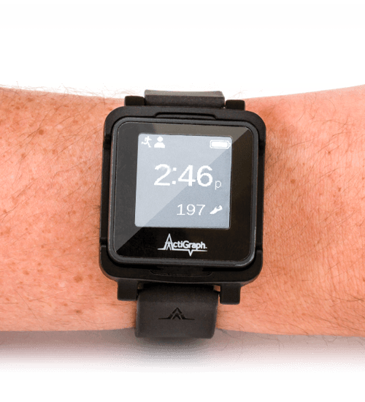

- To help us identify the time that you are lying in bed with the intention of sleeping, please complete the table below each day:

Day | Went to Bed | Got out of bed
Example | 10:35pm | 8:15am
1

2

3

4

5

6

7

Please go to the next page.

- We ask that you attempt to wear the device at all times. If you must remove it for longer than 30 minutes for any reason, please note the reason why and the day and time the device was removed from your wrist on the chart below. Please also note when the device was replaced on your wrist.

 | Day and Time removed | Day and Time replaced | Reason for removal
Example | 11/15/2019 5:55pm | 11/15/2019 6:30pm | Went swimming
1
2
3
4

Return Instructions

- Your device should be removed from your wrist no earlier than:

Date and time:

After seven days, please remove the device and return it in the padded mailer provided to you during your clinic visit.

- Please note the date you removed the device for the last time:

Date:

RETURN THIS SHEET WITH YOUR PHYSICAL ACTIVITY MONITOR.

